**CHAPTER EIGHT**

**STATISTICS-PART ONE**

Introduction:

In a simplified version, statistics may be defined as the branch of mathematics which is concerned with the collection of data, subjecting it to a careful study and coming out with useful information. Some of the statistical parameters are:

(1) The frequency:

The frequency of a number is the number of times that it occurs. For example, consider the following data: 2,2,3,,5,2,4,2,3,7 and 5.

The frequency of 2 is 4 and the frequency of 5 is 2

(2) The range:

The range of a group of numbers is the difference between the lowest and highest number. For example consider the numbers 2, 8, 5, 2, 6, 3, 10, 6, 5 and 9.

The range = 10 – 2 = 8.

(3) The mode:

The mode of a group of numbers is the one which has the highest occurrence.

* For example consider the numbers 2, 7, 3, 7, 7, 5, 6, 7, 4, 5. The mode is 7.
* Also the mode of the following numbers i.e. 10, 10, 15, 10, 20, 11, 11 9, 15, 13, 14 is 10.
* It is possible for a data to have two or three modes.
* A data with two modes is said to be bimodal.
* For example considering the numbers 10, 11, 10, 9, 10, 12, 13, 12, 15, 20 and 12, the mode is 10 and 12 since they have the same frequency.
* A data with three modes is said to be trimodal.
* For example considering the numbers 10, 11, 10, 11, 9, 8, 13, 15, 7 and 7, the mode is 10, 11 and 7.
* Sometimes the mode may not exist at all. For example a data such as 10, 10, 11, 11, 12, 12, 13, 13 has no mode.

Q1.

|  |  |
| --- | --- |
| Number | Frequency |
| 2  3  4  5 | 4  8  2  1 |

Find the mode of the given table.

Soln.

The mode is 3 since it has the highest occurrence or frequency.

2).

|  |  |  |  |  |  |  |
| --- | --- | --- | --- | --- | --- | --- |
| Age/years | 2 | 3 | 4 | 5 | 6 | 7 |
| Frequency | 10 | 2 | 30 | 21 | 25 | 17 |

Find the ages of pupils in a class are shown in the given table. Determine the mode.

Soln.

The mode is 4 since it has the highest frequency.

3). The median:

The median of a group of numbers is the one which comes exactly in the middle when they are arranged in order.

a). Find the median of 5, 2, 3, 7 and 1.

Soln.

Arrange them in order

=>1, 2, (3), 5, 7

The median is 3.

2). Find the median of 9, 4, 3, 8, 5, 3 and 2.

Solution

Arrange them in order =>

2, 3, 3, (4), 5, 8, 9.

The median is 4.

N/B: It is possible to get two numbers as the median.

3). Find the median of 5, 1, 4, 3.

Soln.

Arrange them in order

1, (3, 4), 5

The median is 3 and 4 or

= $\frac{3+4}{2}$ = 7/2 = 3.5.

4). Find the median of 7, 10, 2, 3, 2, 1, 5, 12

Solution

Arrange them in order

=>1, 2, 2, (3, 5), 7, 10, 12.

The median is 3 and 5.

**Formula for finding the median`s position :**

The position of the median is given by $\frac{N + 1}{2}$,

Where N = the number of items.

1). Find the median of 3, 1, 2.

Soln.

Arrange the numbers in order

=>1, 2, 3

N = 3, median`s position = $\frac{N + 1}{2}=\frac{3 + 1}{2}=\frac{4}{2} =2,$

⇒ the median is the second item after the numbers have been arranged in order i.e. the median = 2.

2). Find the median of 5, 2, 2 3, 1, 8, 4.

Soln.

Arrange the numbers in order

=> 1, 2, 2, 3, 4, 5, 8.

Since the numbers are 7=>

N = 7.

Position of the median = $\frac{N + 1}{2}$ = $\frac{7 + 1}{2}=\frac{8}{2}=4$,

⇒ the fourth item is the median. The median = 3.

N/B: If we calculate the position of the median and get a decimal, then two numbers constitute the median .

3). Find the median of 2, 1, 7, 5

Solution

Arrange them in order

=>1, 2, 5, 7

N = 4.

Position of the median = $\frac{N + 1}{2}$

= $\frac{4 + 1}{2}=\frac{5}{2}=2\frac{1}{2}$ or 2.5

Since 2 ½ lies between 2 and 3 the median is the second and third items i.e. 2 and 5 or the median

$\frac{2 + 5}{2}$ = 3.5.

4). Find the median of 5, 10, 6, 3, 7, 2, 1, 1.

Solution

Arrange them in order

⇒1, 1, 2, 3, 5, 6, 10.

⇒ N = 8.

The position of the median = $\frac{N + 1}{2}=\frac{8 + 1}{2}=\frac{9}{2}=4\frac{1}{2} or 4.5$.

The median is the 4th and the 5th items = 3 and 5.

5) You are given the table below. Determine the median.

|  |  |
| --- | --- |
| Number | Frequency |
| 1  2  3  5 | 2  1  3  1 |

$\sum{f}$ = 7

N/B: The given data can be represented as,

1, 1, 2, 3, 3, 3, 5.

The total frequency ($\sum{f) }$ = N

⇒ N = 7.

Position of the median = $\frac{N + 1}{2}$ = $\frac{7 + 1}{2} = \frac{8}{2} = 4.$

⇒ the median is the fourth item = 3.

6). Find the median of the given table

|  |  |
| --- | --- |
| X | F |
| 2  3  4  5  6 | 2  2  1  1  2 |

Soln.

Total frequency = $\sum{f}$ = 2 + 2 + 1 + 1 + 2

⇒ $\sum{f}$ = 8 => N = 8.

Position of the median = $\frac{N + 1}{2}$ = $\frac{8 + 1}{2}$ = $\frac{9}{2}$ = 4 ½

⇒ the 4 th and 5th items constitute the median. The given data can also be represented as 2, 2, 3, 3, 4, 5, 6, 6.

⇒ th 4thand 5thitems = 3 and 4,

⇒ the median = 3 and 4 or the median = 3+4/2 = 7/2 = 3.5

**The mean:**

This is also known as the average.

**Types of means :**

- At this level, three types of means will be considered, and these are

a). the mean of ungrouped data.

b). the mean of grouped data.

c). the assumed mean.

N/B 1). An example of an ungrouped data is given next.

|  |  |  |  |  |
| --- | --- | --- | --- | --- |
| Age/years | 10 | 11 | 12 | 13 |
| Frequency | 10 | 5 | 10 | 4 |

ii). An example of a grouped data is

|  |  |  |  |  |
| --- | --- | --- | --- | --- |
| Age/yrs | 5 -10 | 11-16 | 17 - 22 | 23 - 28 |
| Freq | 2 | 9 | 10 | 3 |

**The mean of an ungrouped data:**

|  |  |  |  |  |  |
| --- | --- | --- | --- | --- | --- |
| Mass/g | 4 | 5 | 6 | 7 | 8 |
| Frequency | 1 | 3 | 10 | 2 | 1 |

The given table shows the masses of eggs collected by a farmer. Calculate the mean or the average.

Soln.

|  |  |  |
| --- | --- | --- |
| Mass  X | Frequency  F | FX |
| 4  5  6  7  8 | 1  3  10  2  1 | 4  15  60  14  8 |

$\sum{f}$ = 17 $\sum{fx}$ = 101

The mean = $\frac{\sum{fx}}{\sum{f}}$ = $\frac{101}{17}$ = 5.9, ⇒ $\overline{x}$ = 5.9.

N/B: The symbol for the mean is $\overline{x}$.

$- \sum{f}$ = the total frequency and this had by adding together all the frequency (F) values.

$_\sum{fx}$ = the total value of all the FX values, and this is had by adding all the FX values.

- The frequency is also the same as the number of occurrence.

Q2.

|  |  |  |  |  |  |
| --- | --- | --- | --- | --- | --- |
| Marks | 4 | 5 | 6 | 7 | 8 |
| Number of occurrence | 1 | 3 | 0 | 6 | 2 |

A class teacher conducted an examination and the marks obtained by the students are as shown in the given table. Calculate the mean mark.

Soln.

|  |  |  |
| --- | --- | --- |
| Mark  X | Frequency  f | FX |
| 4  5  6  7  8 | 1  3  0  6  2 | 4  15  0  42  16 |

$\sum{f}$ = 12 $\sum{fx}$ = 77

The mean = $\overline{x}$ = $\frac{\sum{fx}}{\sum{f}}$ = 77/12 = 6.4.

3). The following table gives the frequency distribution of the ages of 62 examination candidates.

|  |  |
| --- | --- |
| Age/ years | Frequency |
| 15  16  17  18  19  20  21 | 10  20  5  10  10  5  2 |

Calculate the average age of the students.

Soln.

|  |  |  |
| --- | --- | --- |
| Age  X | Frequency  F | FX |
| 15  16  17  18  19  20  21 | 10  20  5  10  10  5  2 | 150  320  85  180  190  100  42 |

$\sum{f}$ = 62 $\sum{fx}$ = 1067

$\overline{x}$ = $\frac{\sum{fx}}{\sum{f}}$ = $\frac{1067}{62}$ = 17yrs.

Q4). Find the mean of the given data

2, 4, 2, 2, 3, 3, 6, 6, 4, 1, 6

N/B: Construct a table first.

- Determine the frequency of each number.

- Determine also the FX values and proceed or continue

Soln.

|  |  |  |
| --- | --- | --- |
| Number  X | Frequency  F | FX |
| 1  2  3  4  6 | 1  3  2  2  3 | 1  6  6  8  18 |

$\sum{f}$ = 11 $\sum{fx}$ = 39

Mean = $\overline{x}$ = $\frac{\sum{fx}}{\sum{f}}$ = 39/11 = 3.5.

You are given these numbers which indicates the marks scored by a group of pupils:

10, 11, 10, 10

10, 11, 13, 12

12, 12, 13, 15

15, 14, 14, 15

Find the mean

Soln.

|  |  |  |
| --- | --- | --- |
| Marks  X | Frequency  F | FX |
| 10  11  12  13  14  15 | 4  2  3  2  2  3 | 40  22  36  26  28  45 |

$\sum{f}$ = 16 $\sum{fx}$ = 197

The mean = $\overline{x}$ = $\frac{\sum{fx}}{\sum{f}}$ = 197/16 = 12.

Q6).

|  |  |  |  |  |
| --- | --- | --- | --- | --- |
| Weight | 2 | 3 | 4 | 5 |
| Frequency | 1 | X | 1 | 2 |

The weights of boys in a group are as shown in the given table. Given that the mean weight is 3.6, calculate the value of x.

Soln.

|  |  |  |
| --- | --- | --- |
| Weight  X | Frequency  F | FX |
| 2  3  4  5 | 1  X  1  2 | 2  3X  4  10 |

$\sum{f}$ = 4 + x $\sum{fx}$ = 16 + 3x

The mean = $\overline{x}$ = $\frac{\sum{fx}}{\sum{f}}$ = $\frac{16 + 3X}{4+ X}.$ Since the mean = 3.6, then 3.6 = $\frac{16 + 3X}{4+ X}$,

⇒ $\frac{3.6}{1}$ = $\frac{16 + 3x}{4 + x}$

Cross multiplying

=> 3.6(4+x) = 1(16+3x)

=> 14.4 + 3.6x = 16 + 3x

=> 3.6x – 3x = 16 – 14.4

=> 0.6x = 1.6

=> X = 1.6/0.6

=> X = 2.7

7).

|  |  |
| --- | --- |
| Mass/g | Number of occurrence |
| 3  4  5  6 | 3  2  1  Y |

The given table shows the masses of sticks used for a project work. If the mean mass of the sticks used is 4, determine the value of y.

Solution

|  |  |  |
| --- | --- | --- |
| Mass  X | Frequency  F | FX |
| 3  4  5  6 | 3  2  1  Y | 9  8  5  6y |

$\sum{f}$ = 6 + y $\sum{fx}$ = 22 + 6y

The mean $\overline{x}$ = $\frac{\sum{fx}}{\sum{f}}$ = $\frac{22 ++ 6y}{6 + y}$

But the mean = 4

4 = $\frac{22 + 6y}{6 + y}$ => $\frac{4}{1}$ = $\frac{22 + 6y}{6 + y}$

Cross multiplying

=> 4(6 + y) = 1(22 + 6y)

=>24 + 4y = 22 + 6y

=>24 + 4y – 22 = 6y

=> 24 – 22 = 6y – 4y

=> 2y = 2

=> y = 2/2 => y = 1.

8). the table below gives the distribution of the number of letters per word in the first fifty words of an essay.

|  |  |  |  |  |  |  |  |  |  |
| --- | --- | --- | --- | --- | --- | --- | --- | --- | --- |
| Number of letters | 1 | 2 | 3 | 4 | 5 | 6 | 7 | 8 | 9 |
| Number of words | 1 | 3 | X | 10 | 12 | y | 6 | 4 | 1 |

If he average number of letters per word is 5, find the values of x and y.

Soln.

Since the number of word = 50

=> 1+3+x+10+12+y+6+4+1 = 50

=> 37+x+y = 50

=> x + y =50 – 37

=> x + y = 13

Let x + y =13 --------------- equation (1).

|  |  |  |
| --- | --- | --- |
| Number of letters  X | Frequency  F | FX |
| 1  2  3  4  5  6  7  8  9 | 1  3  X  10  12  Y  6  4  1 | 1  6  3x  40  60  6y  42  32  9 |

$\sum{f}$ = $37+x+y$, $\sum{fx=}190+3x+6y$

The mean = $\frac{\sum{fx}}{\sum{f}}$ = $\frac{190+3x+6y}{37+x+y}$

Since the mean = 5

=> 5 = $\frac{190+3x+6y}{37+x+y}$

=> $\frac{5}{ 1 }$ = $\frac{190+3x+6y}{37+x+y}$

Cross multiplying

=> 5(37+x+y) = 1(190+3x+6y)

=>185 + 5x +5y = 190 + 3x + 6y

=> 5x + 5y = 190 + 3x + 6y – 185

=> 5x – 3x + 5y = 190 – 185 + 6y

=> 5x – 3x + 5y – 6y = 190 – 185

=> 2x – y = 5

Let 2x – y = 5 ----------------equation (2)

Now solve equation (1) and equation (2) simultaneously i.e.

x + y = 13 -------- (1)

2x – y = 5 -------- (2)

Equation (1) + equation (2) gives us

3x = 18

=> X = 18/3 = 6.

From equation (1), x + y = 13

=> 6 + y = 13

=> y = 13 – 6

=> y = 7

9).

|  |  |  |  |  |  |
| --- | --- | --- | --- | --- | --- |
| Weight/kilogram | 1 | 2 | 3 | 4 | 5 |
| Number of stones | 2 | x | 1 | y | 3 |

The given table gives information on how a block manufacturer used 17 stones to manufacture a number of blocks. Given the mean weight of the blocks manufactured to be 3.7kg, determine the value of x and y.

Soln.

Since the total number of stones used = 17,

2 +x + 1 + y + 3 = 17

=> 6 + x + y = 17

=> x + y = 17 – 6

=> x + y = 11 ------------------------------ equation (1)

|  |  |  |
| --- | --- | --- |
| Weight  X | Frequency  F | FX |
| 1  2  3  4  5 | 2  X  1  Y  3 | 2  2x  3  4y  15 |

$\sum{f}$ = 6 + x + y $\sum{fx}$ = 20 + 2x + 4y

Mean = $\frac{\sum{fx}}{\sum{f}}$ = $\frac{20+2x+4y}{6+x+y}$

But the mean = 3.7

⇒3.7 = $\frac{20+2x+4y}{6+x+y}$,

⇒ $\frac{3.7}{1}$ = $\frac{20+2x+4y}{6+x+y},$

⇒3.7(6 + x + y) = 1(20 + 2x +4y)

⇒22.2 + 3.7x + 3.7y =20 + 2x + 4y

⇒22.2 + 3.7x + 3.7y – 20 = 2x +4y

⇒22.2 – 20 + 3.7x = 2x + 4y – 3.7y

⇒2.2 + 3.7x = 2x + 0.3y

⇒2.2 = 2x + 0.3y – 3.7x

⇒2.2 = 2x– 3.7x + 0.3y

⇒ -1.7x + 0.3y = 2.2

Multiply through using 10, in order to remove the decimal points

⇒ -1.7 x 10 + 0.3y x 10 = 2.2 x10

=> -17x + 3y = 22

Let -17x + 3y = 22 ------------------ equation (2).

Now consider equation (1) and equation (2)

$x+y=11$-----------------------------eqn (1)

$-17x+3y=22$--------------------- eqn(2)

Equation (1) x -3

=> -3x – 3y = -33 ---------------------- eqn(3)

Add equation (2) and equation (3)

i.e. -17x + 3y = 22

+ -3x – 3y = -33

-20x = -11

From -20x = -11 => x = $\frac{-11}{-20}=0.5 approx.$

Put x = 0.5 into eqn (1), i.e. x + y = 11

=> 0.5 + y = 11 => y = 11 - 0.5 = 10.5

**The mean of grouped data:**

-The manner of calculating the mean of a grouped data is almost the same as that of the ungrouped data.

- In this case, there is a slight modification, which is the introduction of a class mark column, with reference to the table.

- To get the class mark for a particular group, we add the lower value to the higher value of the group and divide the answer by 2.

- For example, to get the class mark for the group 2 – 4, we add the 2 to the 4 and divide our answer by 2.

⇒ the class mark = $\frac{2 + 4}{2}$ = $\frac{6}{2}$ = 3.

- For the class mark of the group 3 – 5, add 3 to 5, and divide the answer by 2

i.e $\frac{3+5}{2}=\frac{8}{2}$ = 4.

1).

|  |  |  |  |  |
| --- | --- | --- | --- | --- |
| Age/yrs | 2 – 4 | 5 – 7 | 8 – 10 | 11 – 13 |
| Frequency | 1 | 3 | 2 | 5 |

The table above shows the age distribution of a group of family members. Calculate the mean age.

Solution

|  |  |  |  |
| --- | --- | --- | --- |
| Group or age | Class mark  X | Frequency  F | FX |
| 2 – 4  5 – 7  8 – 10  11 – 13 | 3  6  9  12 | 1  3  2  5 | 3  18  18  60 |

$\sum{f}$ = 11 $\sum{fx}$ = 99

The mean = $\overline{x}$ = $\frac{\sum{fx}}{\sum{f}}$ = $\frac{99}{11}$ = 9.

2).

|  |  |  |  |  |  |
| --- | --- | --- | --- | --- | --- |
| Mass/g | 20 – 29 | 30 – 39 | 40 – 49 | 50 – 59 | 60 – 69 |
| Number of occurrence | 5 | 2 | 10 | 15 | 1 |

The masses of eggs collected by a farmer are as shown in the given tabulation. Determine the mean.

Solution

|  |  |  |  |
| --- | --- | --- | --- |
| Group or mass/g | Class  X | Frequency  F | FX |
| 20 – 29  30 – 39  40 – 49  50 – 59  60 – 69 | 24.5  34.5  44.5  54.5  **6**4.5 | 5  2  10  15  1 | 122.5  69  445  817.5  64.5 |

$\sum{f}$ = 33 $\sum{fx}$ = 1518.5

The mean = $\overline{x}$ = $\frac{\sum{fx}}{\sum{f}}$ = 1518.5/33 = 46,

⇒ $\overline{x}$ = 46.

N/B:

To get the class mark for the first group i.e the 20 – 29 group, add 20 to 29, and divide the answer by 2.

i.e. $\frac{20 + 29}{2}$ = 49/2 = 24.5.

3). The weights in kilogram, of a group of animals found at a farm are as follows:

2 3 2 4 14

5 6 6 5 16

2 3 4 7 4

8 11 10 7 6

4 2 4 12 7

12 13 13 12 10

11 16 15 16 14

Using the class interval 2 – 4, 5 – 7, etc, calculate the mean.

Solution

|  |  |  |  |
| --- | --- | --- | --- |
| Group/weight | Class mark  X | Frequency  F | FX |
| 2 – 4  5 – 7  8 – 10  11 – 13  14 – 16 | 3  6  9  12  15 | 11  8  3  7  6 | 33  48  27  84  90 |

$\sum{f}$ = 35 $\sum{fx}$ = 282

$\overline{x}$ = $\frac{\sum{fx}}{\sum{f}}$ = 282/35 = 8.1

N/B: -You must determine in this case, the frequency of each group.

- For example for the first group i.e 2- 4, we count or determine the number of weights which falls within this group.

- Since 11 weights fall within this group, then the frequency is 11.

- For the 8 – 11 group, only three weights fall within this group. The frequency of this group is 3.

4). The marks had in an examination by a group of candidates are presented as:

2 29 33 16 8 12

38 42 27 14 20 17

51 55 60 43 32 48

42 50 30 28 19 58

62 61 9 39 44 59

By using the grouping 0 – 9, 10 – 19 etc, calculate the mean.

Solution

|  |  |  |  |
| --- | --- | --- | --- |
| Group of marks | Class mark  X | Frequency  F | FX |
| 0 – 9  10 – 19  20 – 29  30 – 39  40 – 49  50 – 59  60 – 69 | 4.5  14.5  24.5  34.5  44.5  54.5  64.5 | 3  5  4  5  5  5  3 | 13.5  72.5  98  172.5  222.5  272.5  193.5 |

$\sum{f}$ = 30 $\sum{fx}$ = 1045

$\overline{x}$ = $\frac{\sum{fx}}{\sum{f}}$ = 1045/30 = 35.

5).

|  |  |  |  |  |
| --- | --- | --- | --- | --- |
| Height/cm | 0 – 2 | 3 – 5 | 6 – 8 | 9 – 11 |
| Frequency | 2 | 1 | x | 1 |

The given table shows the heights of poles used by a contractor for a project. Given that the average height of pole used is 5.2m, calculate the values of x.

Solution

|  |  |  |  |
| --- | --- | --- | --- |
| Group or height | Class mark  X | Frequency  F | FX |
| 0 – 2  3 – 5  6 – 8  9 – 11 | 1  4  7  10 | 2  1  X  1 | 2  4  7x  10 |

$\sum{f}$ = 4 +x $\sum{fx}$ = 16 + 7x

$\overline{x}$ = $\frac{\sum{fx}}{\sum{f}}$ $=\frac{16 + 7x}{4 + x}$. Since the mean = 5.2, then $\frac{5.2}{1}$ = $\frac{16 + 7x}{4 + x}$

⇒ 5.2(4 + x) = 1(16 + 7x)

⇒ 20.8 + 5.2x = 16 + 7x

⇒20.8 -16 = 7x – 5.2x

⇒ 4.8 = 1.8x

⇒1.8x = 4.8

⇒X = 4.8/1.8

⇒X = 2.7

**The cumulative frequency curve:**

- This is also known as the ogive.

- It is drawn only after the construction of the cumulative frequency table.

1).

|  |  |  |  |  |  |  |  |
| --- | --- | --- | --- | --- | --- | --- | --- |
| Age/yrs | 0 – 2 | 3 – 5 | 6 – 8 | 9 – 11 | 12 – 14 | 15 – 17 | 18 – 20 |
| Frequency | 5 | 7 | 12 | 10 | 3 | 4 | 9 |

The given table shows the age distribution of kids in a club.

a). Construct a cumulative frequency table for it.

b). use it to draw the cumulative frequency curve.

1. Solution

|  |  |  |  |
| --- | --- | --- | --- |
| Age/yrs | Less than or upper limit | Frequency  F | Cumulative frequency |
| 0 – 2  3 – 5  6 – 8  9 – 11  12 – 14  15 – 17  18 – 20 | 2.5  5.5  8.5  11.5  14.5  17.5  20.5 | 5  7  12  10  3  4  9 | 5  12  24  34  37  41  50 |

$\sum{f}$ = 50

N/B: -The last cumulative frequency value must always be equal to the total frequency.

- To get the upper limit of a group, add 0.5 to the highest value of that group.

- For example considering the first group that is 0 – 2, the highest number is 2.we therefore add 0.5 to the 2 to get 2.5 as the upper limit.

Also for the second group i.e the 3 – 5 group, we add 0.5 to the 5 to get 5.5 as the upper limit of the group.

|  |  |
| --- | --- |
| Frequency | Cumulative frequency |
| 5  7  12  10 | 5  12  24  34 |

-The manner of completing the cumulative frequency column is what has just been shown.

- First write the first frequency which is 5 as the first cumulative frequency value.

- Add this 5 to the 7 to get 12. This 12 is then added to the 12 to get 24.

- Add this 24 to the 10 to get 34 and the process continues.

(b) To get the cumulative frequency curve, we plot the cumulative frequency values on the y - axis against the upper limit values on the x - axis.

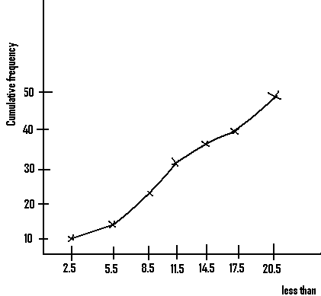

2).

|  |  |
| --- | --- |
| Mass/kg | Frequency |
| 3 – 7  8 – 12  13 – 17  18 – 22  23 – 27  28 – 32  33 – 37  38 – 42  43 – 47  48 – 52 | 10  4  2  3  8  5  6  7  8  7 |

The masses of stones used in the construction of a dam are given in the table.

a). Construct a cumulative frequency table for the distribution.

b). Draw the ogive for the distribution.

c). Use it to determine the

i). Upper quartile

ii). Lower quartile

d). Find

i). the interquartile range.

ii). The semi interquartile range.

Soln.

a).

|  |  |  |  |
| --- | --- | --- | --- |
| Mass/kg | Less than or upper limit | Frequency | Cumulative frequency |
| 3 – 7  8 – 12  13 – 17  18 – 22  23 – 27  28 – 32  33 – 37  38 – 42  43 – 47  48 – 52 | 7.5  12.5  17.5  22.5  27.5  32.5  37.5  42.5  47.5  52.5 | 10  4  2  3  8  5  6  7  8  7 | 10  14  16  19  27  32  38  45  53  60 |

$\sum{f}$ = 60

N/B: -The total frequency = the last cumulative frequency value.

-If these two values differ, then there must be a mistake somewhere in the table.

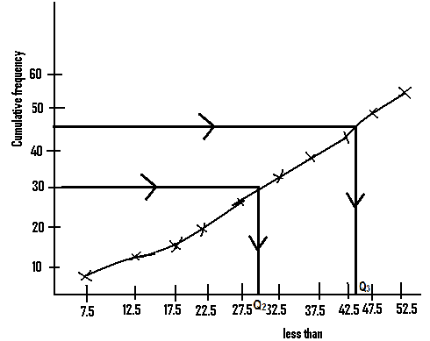

c). i). - The upper quartile is represented by Q3 and to find it we must find ¾ of the total frequency = ¾ x 60 = 45.

- We next locate this 45 on the cumulative frequency axis.

- From this point we draw a straight line to meet the curve, and at the point that it meets the curve, another straight line is drawn to meet the x- axis or the less than axis.

- The point where it meets the x - axis is the value of the upper limit.

⇒ Q 3 = 45 approx.

ii).The middle quartile is the same as the median. And it is represented by Q2.

- To get this, we find ½ of the total frequency = ½ x 60 = 30.

- We then locate the position of this 30 on the cumulative frequency axis and go through the same previous steps.

∴Q 2 = 30 approx.

i).For the lower quartile Q 1, we find ¼ of the total frequency and go through the steps already discussed.

¼ of the total frequency = ¼ x 60 = 15

⇒ Q 1 = 12.5 approx.

d)i). The inter quartile range = Q 3 – Q 1 = 45 – 12.5 = 32.5.

ii).The semi interquartile range = $\frac{Q_{3} - Q_{1}}{2}=\frac{45 - 12.5}{2}=\frac{32.5}{2}=16 approx .$

Q3. The following are the ages in years of workers within a company.

93 67 35 40

64 50 51 70

95 57 34 65

82 28 62 79

68 63 41 43

73 35 58 61

73 46 25 72

70 63 44 55

88 52 44 30

71 56 35 49

Using the class interval of 21 – 30, 31 – 40 . . .

a). form the cumulative frequency table.

b). draw the ogive.

c). determine the upper quartile and the lower quartile.

d). determine the interquartile range.

e). determine also the semi interquartile range.

Soln.

|  |  |  |  |
| --- | --- | --- | --- |
| Age/yrs | Less than | Frequency | Cumulative frequency |
| 21 – 30  31 – 40  41 – 50  51 – 60  61 – 70  71 – 80  81 – 90  91 – 100 | 30.5  40.5  50.5  60.5  70.5  80.5  90.5  100.5 | 3  5  7  6  10  5  2  2 | 3  8  15  21  31  36  38  40 |

$\sum{f}$ = 40

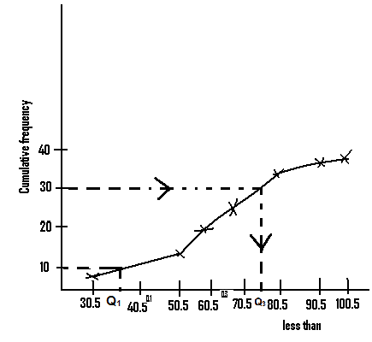

c). For the upper quartile, Q3, we find ¾ of the total frequency

= ¾ x 40 = 30

From the curve, Q3 = 75 approx.

For the lower quartile Q1, we find ¼ of the total frequency.

= ¼ x 40 = 10

From the table, Q1 = 32 approx.

d). The interquartile range

= Q3 – Q1 = 75 - 32 = 43.

e). The semi inter quartile range

= $\frac{Q_{3 - Q_{1}}}{2}=\frac{75-32 }{2}=21.5$

Q4.

|  |  |  |  |  |  |  |  |  |  |  |  |  |  |  |  |
| --- | --- | --- | --- | --- | --- | --- | --- | --- | --- | --- | --- | --- | --- | --- | --- |
| No. of accidents | 0 | 1 | 2 | 3 | 4 | 5 | 6 | 8 | 10 | 11 | 13 | 15 | 17 | 18 | 19 |
| No. of days | 20 | 10 | 8 | 7 | 5 | 3 | 3 | 5 | 4 | 4 | 3 | 2 | 2 | 3 | 1 |

Study carefully this given data.

1. By using the group intervals 0 -2, 3 - 5, 6 - 8, etc…….. prepare a frequency distribution table for the given data.
2. Construct the cumulative frequency table.
3. Draw the cumulative frequency curve.
4. Using your frequency curve, determine

( i) the median.

(ii) the upper quartile.

**N/B:** - For the group intervals 0 - 2, the frequency = 20 + 10 + 8 = 38.

* For the group interval 3 -5, the frequency = 7 + 5 + 3 = 15.
* For the group interval 6 - 8, the frequency = 3 + 5 = 8.
* For the group interval 9 -11, the frequency = 4 + 4 = 8.
* For the group interval 12-14, the frequency = 3.
* For the group interval 15 -17, the frequency = 2 + 2 = 4.
* For the group interval 18 – 20, the frequency = 3 + 1 = 4.

Soln.

1. From the above analysis, the frequency distribution table becomes as shown next.

|  |  |  |  |  |  |  |  |
| --- | --- | --- | --- | --- | --- | --- | --- |
| Group | 0 – 2 | 3 – 5 | 6 - 8 | 9 - 11 | 12 – 14 | 15 – 17 | 18 – 20 |
| Freq. | 38 | 15 | 8 | 8 | 3 | 4 | 4 |

(b)

|  |  |  |  |
| --- | --- | --- | --- |
| Group | Less than | Frequency | Cumulative Frequency |
| 0 – 2  3 – 5  6 – 8  9 – 11  12 – 14  15 – 17  18 - 20 | 2.5  5.5  8.5  11.5  14.5  17.5  20.5 | 38  15  8  8  3  4  4 | 38  53  61  69  72  76  80 |

$$\sum{f=80}$$

(c)Using this table, draw the cumulative frequency curve and proceed on.

**HISTOGRAM DATA:**

Two types of histograms will be considered and these are

1). Histogram of ungrouped data

2). Histogram of grouped data

**HISTOGRAM OF UNGROUPED:**

1).

|  |  |  |  |  |  |  |
| --- | --- | --- | --- | --- | --- | --- |
| Age/yrs | 10 | 11 | 12 | 13 | 14 | 15 |
| Frequency | 5 | 10 | 2 | 12 | 4 | 3 |

The age distribution of pupils in a class is as indicated in the above table. Represent this on a histogram.

Soln.

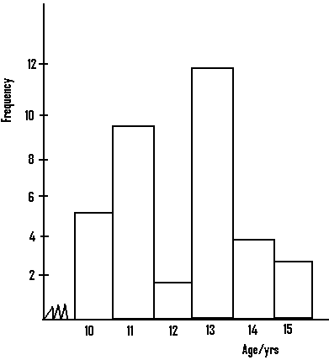

N/B: - In drawing histograms, spaces are not left between the bars.

-For the types of histograms stated in the core mathematics syllabus, the sizes of the bars drawn must be the same.

2).

|  |  |
| --- | --- |
| Age/yrs | Number of occurrence |
| 15  16  17  18  19  20  s21 | 10  20  56  34  19  7  5 |

The given table gives the frequency distribution of the ages of 150 boys in a school. Represent this on a histogram.

Soln.

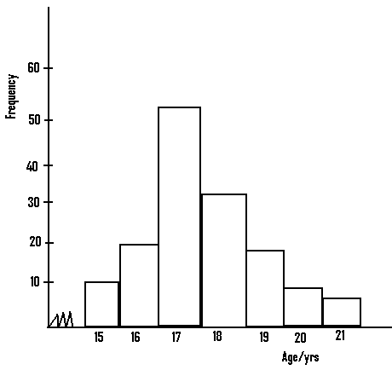

Q3). You are given the following numbers

10 13 10 11 11 13

10 12 12 15 14 14

10 11 15 13 13 13

14 15 13 14 10

Represent this on a histogram.

Solution

|  |  |
| --- | --- |
| Number | Frequency |
| 10  11  12  13  14  15 | 5  3  2  6  4  3 |

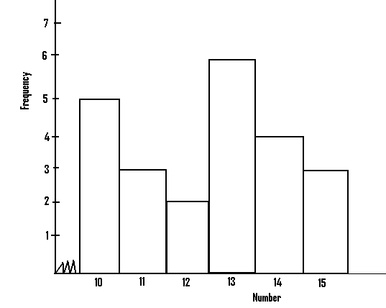

**Histogram of grouped data:**

- For the histogram of a grouped data, the class boundaries of each of the group must be determined, before we can draw such a histogram.

-To get the class boundaries for a particular group, we decrease the number on the left hand side by 0.5 and increase that on the right hand side by 0.5.

- For example the class boundaries for the group 2 – 4 is 1.5 – 4.5, and that for the group 10 – 12 will be 9.5 – 12.5.

1).

|  |  |  |  |  |  |
| --- | --- | --- | --- | --- | --- |
| Mass/g | 2 – 4 | 5 – 7 | 8 – 10 | 11 – 13 | 14 – 16 |
| Frequency | 2 | 8 | 10 | 6 | 4 |

The masses of pens manufactured by a company are as shown in the table. Represent this on a histogram.

Solution

|  |  |  |
| --- | --- | --- |
| Mass/g | Class boundaries | Frequency |
| 2 – 4  5 – 7  8 – 10  11 – 13  14 – 16 | 1.5 – 4.5  4.5 – 7.5  7.5 – 10.5  10.5 – 13.5  13.5 – 16.5 | 2  8  10  6  4 |

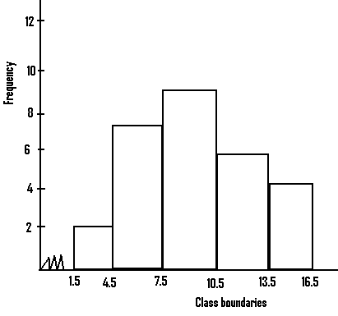

2).

|  |  |
| --- | --- |
| Length/m | Frequency |
| 45 – 49  50 – 54  55 – 59  60 – 64  65 – 69  70 – 74 | 1  3  6  7  6  4 |

The lengths of sticks collected by a farmer are as shown in the given table. Represent this on a histogram.

Solution

|  |  |  |
| --- | --- | --- |
| Length/m | Class boundaries | Frequency |
| 45 – 49  50 – 54  55 – 59  60 – 64  65 – 69  70 – 74 | 44.5 – 49.5  49.5 – 54.5  54.5 – 59.5  59.5 – 64.5  64.5 – 69.5  69.5 – 74.5 | 1  3  6  7  6  4 |

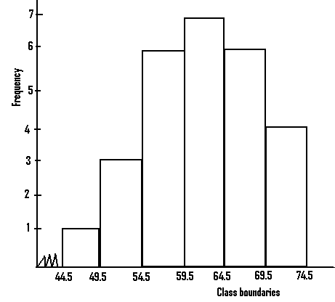

3). A class teacher conducted a test and the marks obtained by the students are as follows :

22 14 22 32 4

6 30 10 39 12

37 22 18 29 10

29 7 13 19 33

11 6 23 8 27

17 9 34 14 31

Using the class interval 4 – 9, 10 – 15 etc. represent this on a histogram.

**N/B**:The class boundaries may also be referred to as the class limits.

Soln.

|  |  |  |
| --- | --- | --- |
| Marks | Class limits | Frequency |
| 4 – 9  10 – 15  16 – 21  22 – 27  28 – 33  34 – 39 | 3.5 – 9.5  9.5 – 15.5  15.5 – 21.5  21.5 – 27.5  27.5 – 33.5  33.5 – 39.5 | 6  7  3  5  6  3 |

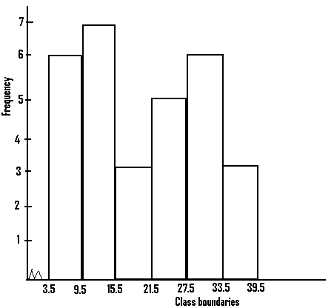

**Statistical Tabulations:**

-The way in which a statistics table is drawn depends on what the question demands.

- If the question demands that we find the mean and draw the histogram, then there two methods we can use.

-In the first method which is a long method, we construct different tables for the mean and the histogram.

-The table for the mean will look as shown next:

|  |  |  |  |
| --- | --- | --- | --- |
| Group | Class mark X | Frequency F | FX |
|  |  |  |  |

-The table for the histogram will be as shown next:

|  |  |  |
| --- | --- | --- |
| Group | Class limits | Frequency |
|  |  |  |

- Looking at these tables, they both contain a column for frequency and the group.

- In the second method which is quite shorter, what these two tables contain are combined to get a single table which will look like:

|  |  |  |  |  |
| --- | --- | --- | --- | --- |
| Group | Class mark  X | Class limits | Frequency  F | FX |
|  |  |  |  |  |

1).

|  |  |  |  |  |  |
| --- | --- | --- | --- | --- | --- |
| Amount/Naira | 5 – 9 | 10 – 14 | 15 – 19 | 20 – 24 | 25 – 29 |
| Number of students | 6 | 3 | 1 | 10 | 8 |

The given table shows the amount had by a group of students in a club.

a). Calculate the mean .

b). Draw a histogram for the distribution.

Solution

|  |  |  |  |  |
| --- | --- | --- | --- | --- |
| Amount /Naira | Class mark  X | Class limits | Frequency  F | FX |
| 5 – 9  10 – 14  15 – 19  20 – 24  25 – 29 | 7  12  17  22  27 | 4.5 – 9.5  9.5 – 14.5  14.5 – 19.5  19.5 – 24.5  24.5 – 29.5 | 6  3  1  10  8 | 42  36  17  220  216 |

$\sum{f}$ = 28 $\sum{fx}$ = 531

a). The mean = $\frac{\sum{fx}}{\sum{f}}$ = $\frac{531}{28}$ = 19.

b).

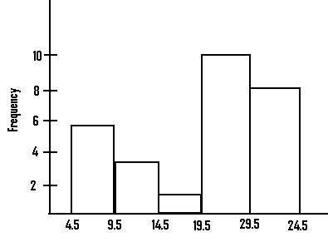

N/B: - Assuming the question wants us to determine the mean and draw the ogive, then we can choose to construct different tables for the mean and the ogive.

-Table for the mean will look as follows:

|  |  |  |  |
| --- | --- | --- | --- |
| Group | Class mark  X | Frequency  F | FX |
|  |  |  |  |

-Our table for the 0give will look as follows:

|  |  |  |  |
| --- | --- | --- | --- |
| Group | Less than | Frequency  F | Cumulative frequency |
|  |  |  |  |

-In the second method, the common items that is group and frequency, of these two tables are combined or represented once to get a table, which will look as.

|  |  |  |  |  |  |
| --- | --- | --- | --- | --- | --- |
| Group | Class marks  X | Less than | Frequency  F | FX | Cumulative frequency |
|  |  |  |  |  |  |

Q2). The weekly payment made to a group of workers in dollars are as follows:

71 56 35 49

30 44 52 88

44 55 63 70

72 25 46 73

61 58 35 73

43 41 63 68

79 62 28 82

65 34 57 90

70 51 50 64

40 35 67 90

Using the class interval of 21 – 30, 31 – 40 …

construct a table for the distribution which will assist you to

a). draw the cumulative frequency curve.

b). determine the mean.

Soln.

|  |  |  |  |  |  |
| --- | --- | --- | --- | --- | --- |
| Group | Class marks  X | Less than | Frequency  F | FX | Cumulative frequency |
| 21 – 30  31 – 40  41 – 50  51 – 60  61 – 70  71 – 80  81 – 90 | 25.5  35.5  45.5  55.5  65.5  75.5  85.5 | 30.5  40.5  50.5  60.5  70.5  80.5  90.5 | 3  5  7  6  10  5  4 | 76.5  177.5  318.5  333  655  337.5  342 | 3  8  15  21  31  36  40 |

$\sum{f}$ = 40 $\sum{fx}$ = 2240

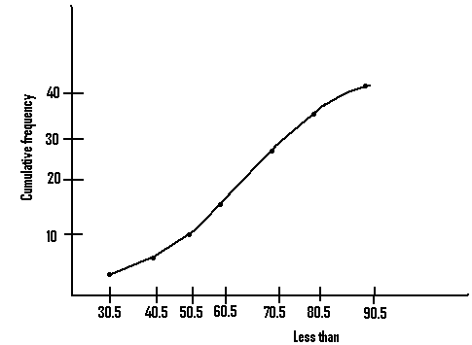

(b)The mean = $\overline{x}$ = $\frac{\sum{fx}}{\sum{f}}$ = $\frac{2240}{40}=56$

N/B = -In certain questions, we may be required to draw the histogram and the ogive.

- In this case we may choose to draw two separate tables, one for the histogram and the other for the 0give.

-The table for the histogram will look as shown next:

|  |  |  |
| --- | --- | --- |
| Group | Class boundaries | Frequency  F |
|  |  |  |

The next table for the 0give will look as shown next:

|  |  |  |  |
| --- | --- | --- | --- |
| Group | Less than | Frequency  F | Cumulative frequency |
|  |  |  |  |

We can also choose to go through the alternative method, in which the two tables are combined to get the next shown table:

|  |  |  |  |  |
| --- | --- | --- | --- | --- |
| Group | Class boundaries | Less than | Frequency  F | Cumulative frequency |
|  |  |  |  |  |

3).The following table shows the different masses of eggs that a farmer had during a certain year.

|  |  |
| --- | --- |
| Mass/g | Number of occurrence |
| 45 – 49  50 – 54  55 – 59  60 – 64  65 – 69  70 – 74  75 – 79 | 7  16  49  86  30  8  4 |

(a) Draw the histogram for the distribution.

b). Construct a cumulative frequency table for the distribution, and use it to draw the 0give.

|  |  |  |  |  |
| --- | --- | --- | --- | --- |
| Group | Class boundaries | Less than | Frequency . F | Cumulative frequency |
| 45 – 49  50 – 54  55 – 59  60 – 64  65 – 69  70 – 74  75 – 79 | 44.5 – 49.5  49.5 – 54.5  54.5 – 59.5  59.4 – 64.5  64.5 – 69.5  69,5 – 74.5  74.5 – 79.5 | 49.5  54.5  59.5  64.5  69.5  74.5  79.5 | 7  16  49  86  30  8  4 | 7  23  72  158  188  196  200 |

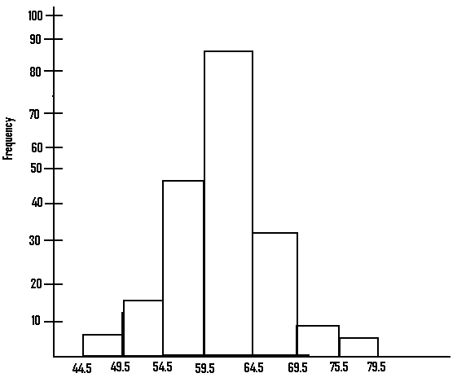

b).

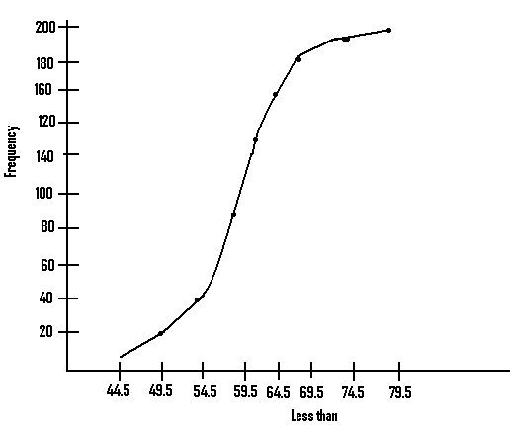

**Bar chart:**

-This may also be referred to as bar graph.

- It looks somehow similar to the histogram, but in bar chart, spaces are left between the bars.

Q1).

|  |  |  |  |  |  |  |
| --- | --- | --- | --- | --- | --- | --- |
| Age/yrs | 10 | 11 | 12 | 13 | 14 | 15 |
| Frequency | 5 | 20 | 30 | 12 | 8 | 16 |

The given table shows the age distribution of a group of friends. Represent this on a bar chart.

Soln.

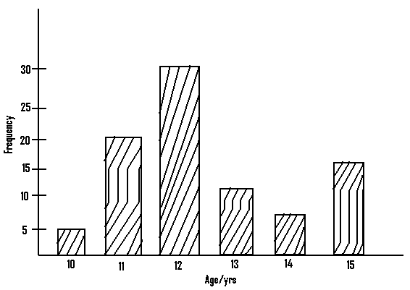

Q2). The amount of rainfall within an area, for a five month period is as shown In the given table. Represent this on a bar graph.

|  |  |  |  |  |  |
| --- | --- | --- | --- | --- | --- |
| **Month** | Jan | Feb | March | April | May |
| Rainfall/ cm | 20 | 50 | 70 | 30 | 15 |

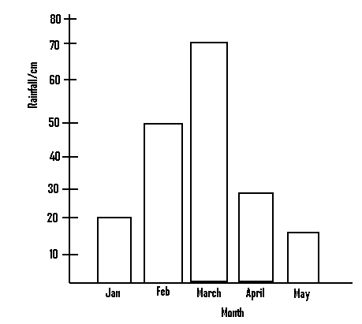

**N/B:** -It is possible to come across questions which even though are not bar graph questions but are closely related to bar graphs.

- In such questions, two corresponding quantities are compared in a tabular form, and one is then asked to represent the given data graphically.

Q1).

|  |  |  |  |  |  |  |
| --- | --- | --- | --- | --- | --- | --- |
| Marks scored in Maths | 80 | 50 | 20 | 90 | 57 | 75 |
| Marks scored in English | 60 | 70 | 40 | 85 | 65 | 55 |

A student compared his scores in Mathematics and English for a series of class tests he wrote, while at school. Represent this graphically.

Soln.

|  |
| --- |
| 0000000  0000000  0000000 |

Let this pattern = his scores in Mathematics.

|  |
| --- |
| //////////  /////////  ////////// |

And let this pattern represent his scores in English.

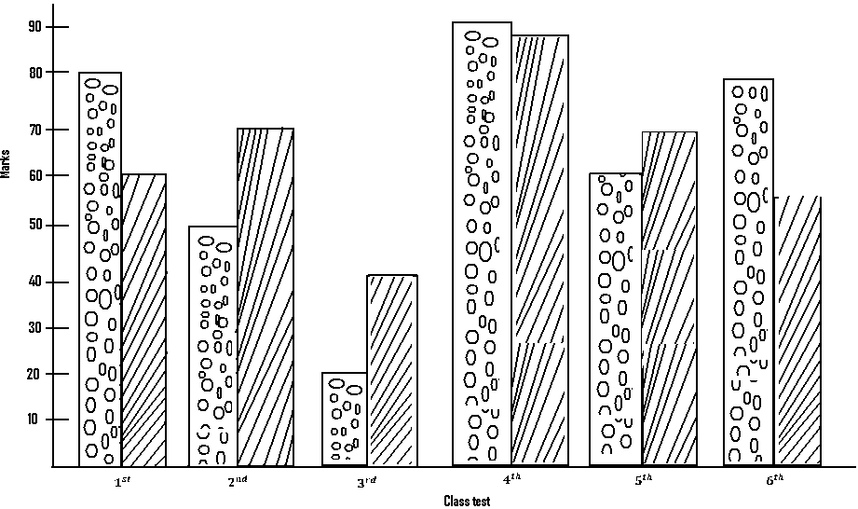

2).

|  |  |  |  |  |  |
| --- | --- | --- | --- | --- | --- |
| Year | 1 | 2 | 3 | 4 | 5 |
| Cocoa production in tones. | 600 | 900 | 850 | 350 | 200 |
| Pineapple production in tonnes. | 800 | 400 | 670 | 720 | 900 |

v

The diagram shows the yearly cocoa and pineapple production from a certain district, for a five year period. Represent this on a graph.

Soln.

|  |
| --- |
| 0000000  0000000  0000000  0000000 |

Let this pattern represent cocoa production

|  |
| --- |
| /////////  ////////  /////// |

and let this pattern represent pineapple production

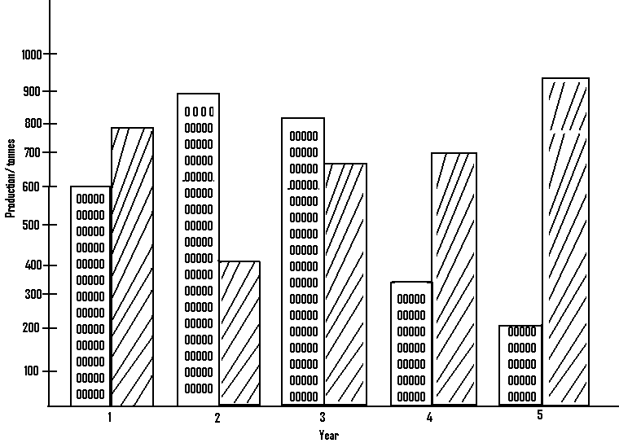

Questions:

Q1).

|  |  |  |  |  |  |
| --- | --- | --- | --- | --- | --- |
| Mass/g | 10 | 11 | 12 | 13 | 14 |
| Frequency | 6 | 4 | 3 | 10 | 7 |

The masses of books sold by a store keeper are as indicated in the given table.

a). Determine the mean

Ans: 12.3

b). Represent this on a histogram

Ans:

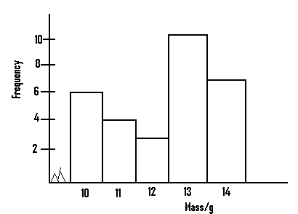

Q2). The marks gained by twenty students in a mathematics class test are as follows:

15 14 15 10

11 14 10 15

10 13 10 12

10 13 15 15

10 15 14 11

a). Determine the mean mark.

Ans: 12.6

b). Represent the given data on a histogram.

Ans:

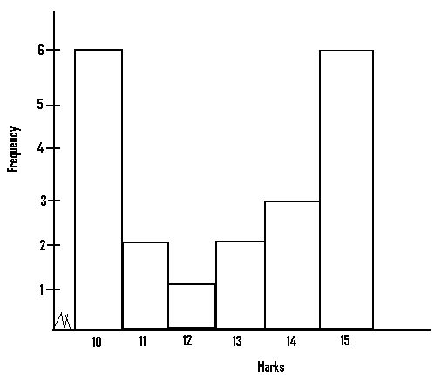

3).

|  |  |  |  |  |  |
| --- | --- | --- | --- | --- | --- |
| Age/yrs | 4 – 6 | 7 – 9 | 10 – 12 | 13 – 15 | 16 – 18 |
| Frequency | 10 | 5 | 20 | 14 | 12 |

The given table shows the age distribution of a group of students

a). Find the mean age

ans: 11.6 yrs.

b). Represent the given data on a histogram.

Ans:

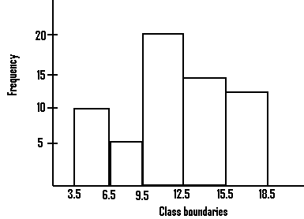

4). The mean weights of stones used by a contractor for a project in kilogram, are as follows:

11 16 15 16 14

12 13 13 12 10

4 2 4 12 7

8 11 10 7 6

2 3 4 7 4

5 6 6 5 16

2 3 2 4 14

By using the grouping 2 – 4, 5 – 7, etc,

a). determine the average weight of the stones used for the project.

Ans: 8kg

b). Represent the given data by means of a histogram.

Ans:

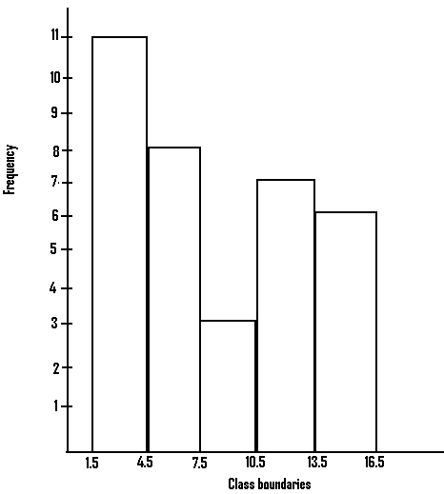

5).

|  |  |  |  |  |  |
| --- | --- | --- | --- | --- | --- |
| Length/cm | 2 | 3 | 5 | 6 | 7 |
| Frequency | 1 | 4 | y | 2 | 2 |

The lengths of sticks used for a project work are as shown in the given table. If the mean is given as 4.74, find the value of y.

Ans: 10 cm

6).

|  |  |  |  |  |  |  |  |
| --- | --- | --- | --- | --- | --- | --- | --- |
| Mass/kg | 0 – 2 | 3 – 5 | 6 – 8 | 9 – 11 | 12 – 14 | 15 – 17 | 18 – 20 |
| Frequency | 5 | 7 | 12 | 10 | 3 | 4 | 9 |

The masses of various foodstuff bought by a trader are as shown in the given table.

a). Determine the mean.

Ans: 10 approx.

b). Draw the 0give for the given distribution.

Ans:

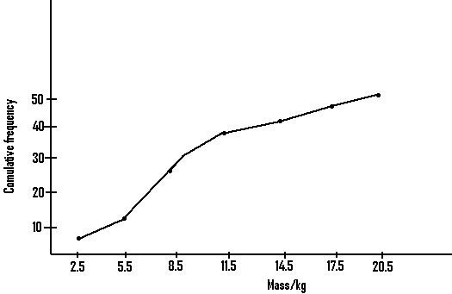

Q7). A class teacher was made to determine the weights of his pupils in kilogram and came out with the following:

71 56 35 49

30 34 52 88

70 63 44 55

73 46 25 72

73 35 58 61

68 63 41 43

82 28 62 79

95 57 34 65

64 50 51 70

93 67 35 40

By using the class interval 21 – 30, 31 – 40 etc,

a). draw the histogram for the given distribution.

Ans:

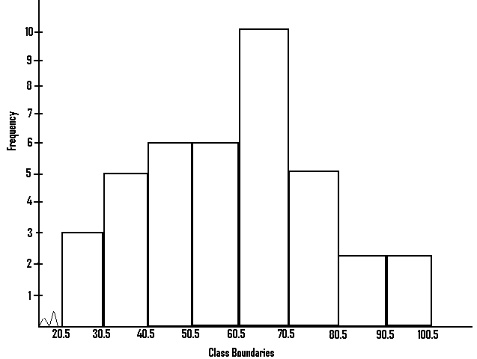

b). Draw the cumulative frequency curve for the above distribution .

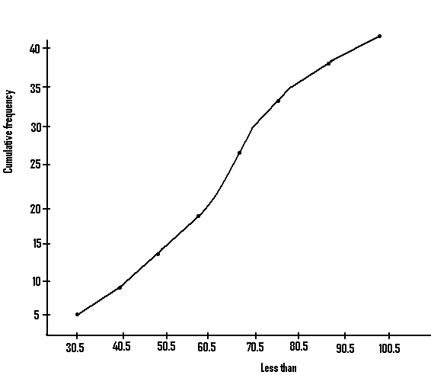

8).

|  |  |  |  |  |
| --- | --- | --- | --- | --- |
| Weight/g | 10 | 12 | 4 | 7 |
| Length/cm | 8 | 6 | 10 | 12 |

A man compared the weights with the lengths of sticks he cut from a tree, and came out with the given table. Represent this on a graph.

Ans:

|  |
| --- |
| 000000  000000  000000 |

Weight

|  |
| --- |
| /////////  ////////  /////// |

Length

